ONCE AGAIN

A NOVEL

**ISBN: 978-1-64385-481-6**

**October 6, 2020**

**“Gripping, gut-churning, and heartfelt—full of lost and last chances.”**

**—Max Gladstone, Hugo, Nebula, and BSFA award-winning co-author of *This Is How You Lose the Time War***

**“A chilling and visceral thrill ride that will both break your heart and lift your soul.”**

**—Janet B. Taylor, author of *Into the Dim***

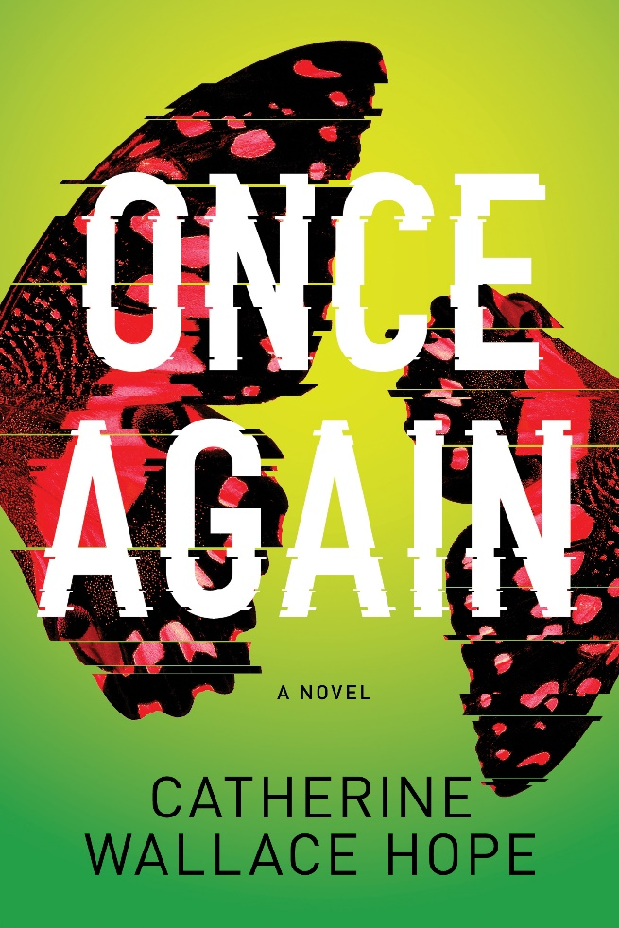

***What if you had one chance to save someone you lost?***

Isolated in the aftermath of tragedy, Erin Fullarton has felt barely alive since the loss of her young daughter, Korrie. She tries to mark the milestones her therapist suggests—like today, the 500th day without Korrie—but moving through grief is like swimming against a dark current.

Her estranged husband, Zac, a brilliant astrophysicist, seems to be coping better. Lost in his work, he's perfecting his model of a stunning cosmological phenomenon, one he predicts will occur today—an event so rare, it keeps him from being able to acknowledge Erin's coinciding milestone.

But when Erin receives a phone call from her daughter's school, the same call she received five hundred days earlier when Korrie was still alive, Erin realizes something is happening. Or happening *again*. Struggling to understand the sudden shifts in time, she pieces together that the phenomenon Zac is tracking may have presented her with the gift of a lifetime: the chance to save her daughter.

Unable to reach Zac or convince the authorities of what is happening, Erin is forced to find the answer on her own. She must battle to keep the past from repeating—or risk losing her daughter for good.

For fans of Ann Patchett and Audrey Niffenegger, ***ONCE AGAIN*** **(Alcove Press / October 6, 2020 / $26.99)** will challenge what you know, as one woman fights to save her daughter.

**Alcove Press**

34 West 27th Street, Floor 10

New York, NY 10001

alcovepress.com

**Follow Catherine at:**

catherinewallacehope.com

 @catwallacehope

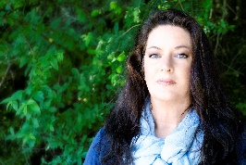

**Catherine Wallace Hope** grew up in Colorado, the setting for her thriller *Once Again*. She earned her degree in creative writing at the University of Colorado. She also delved into dance in New York and art and psychology in California. When she returned to Colorado, she became an instructor at the renowned Lighthouse Writers Workshop, offering creativity workshops for writers. Currently, she and her family are living on an island in the Pacific Northwest where they serve at the pleasure of two astonishingly spoiled dogs.